**Project Assumption:**

**Suspension:**

To assist the rover in traversing complex and uneven terrains, a modified double-rocker suspension has been designed. Based on the rover weight, wheel configurations and center of mass of the rover, the specifications of the control arms and dampers are calculated to provide an initial joint angle for both the control arms concerning the chassis in a no-load condition. The angle between the suspension rods is 120 degrees and for distributing the load properly a truss support structure has been designed in suspension. The differential is connected below the chassis to perfectly balance our chassis along with all the components. The outer diameter of rods is 35mm and inner diameter is 30mm.

 A structural analysis performed on Fusion 360 revealed that the maximum deformation caused by an application of 250 N on one side was 0.04558 mm.

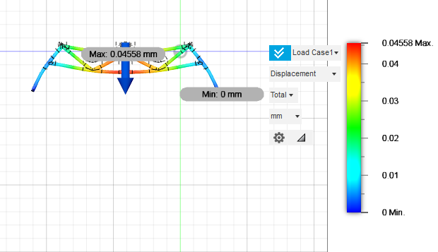

**Chassis:**

The dimensions of the chassis are 800 mm x 600 mm x 200 mm with a ground clearance of 280 mm. The length of the rover is 954 mm. The rectangular structure of the chassis was manufactured using 25mmx25mm T-slots of Aluminium 6063. A structural analysis performed on Fusion 360 revealed that the maximum deformation caused by an application of 500 N was 0.01466 mm. A square box made of Perspex (TM) GS Acrylic Cast Sheet is designed for the rover that contains most of the subsystem components, leaving sufficient space for the antenna and robotic arm. It is used to protect the electrical components from external elements like radiation and EMF. The enclosure also contains vents and fans to prevent the system from overheating and is equipped with a wire harness for easier wiring and connections. The enclosure for the PCB has an area enough to accommodate Arduino. The PCB is placed at a height of 3 cm on top of the Arduino. The rectangular cavity on the top surface allows all the wires to connect to the PCB pins and the bottom half has an opening for the power cable. The box for electrical components is attached to the chassis using different types of customized clamps.

The mass of the entire chassis is 4.78kg.

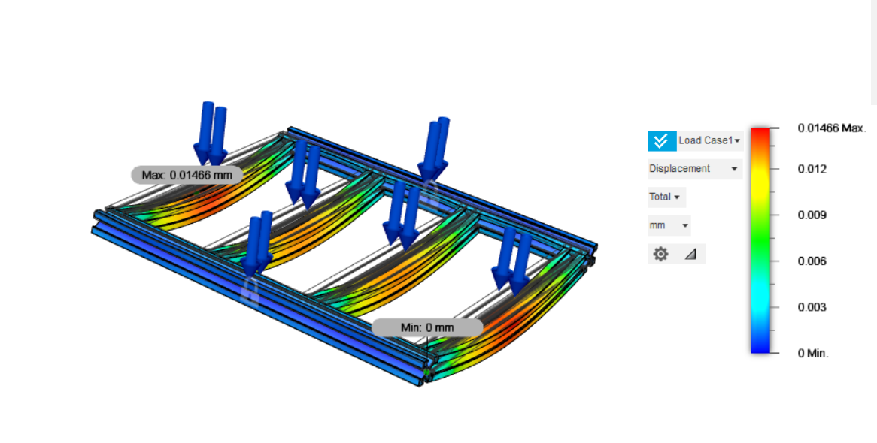

**Wheels:** Because of their low pressure and lightweight nature, the 270-mm polyurethane beach wheels used on the rover provide extra damping to help it get over rough terrain. The low pressure of the tyre aids the suspension system by soaking up some of the shock waves that are transmitted to the vehicle from the road surface. The motor is mounted inside a custom-built hub to keep the wheels small and prevent movement obstruction on uneven ground. To keep the wheels small and prevent movement obstructions on uneven ground, the motor is mounted inside a custom-built hub. The rover is able to maintain traction and move forward efficiently thanks to the beach wheels' one-of-a-kind design that provides a better grip and prevents slippage. The rover is less likely to fall over or become mired in unstable sand with this improved stability. Beach-wheeled rovers can traverse a wide range of terrain, making them ideal for use in scientific exploration, outdoor recreation, and SAR missions.  **Robotic Arm:**

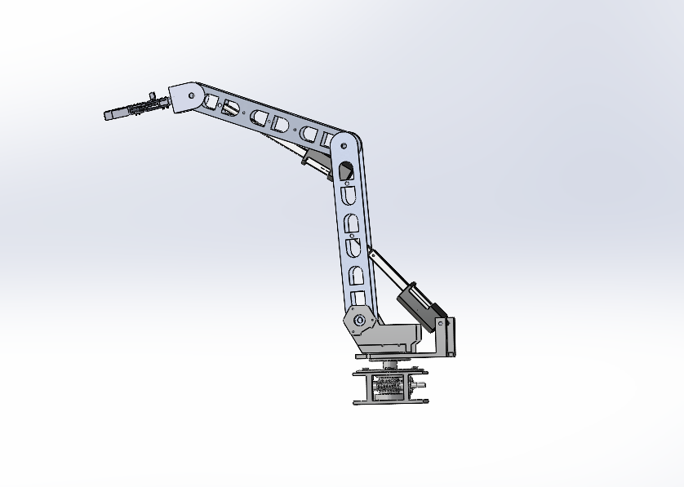A custom-designed robotic arm with five degrees of freedom and a reach radius of 1000mm has been meticulously developed to provide invaluable assistance to the rover in performing maintenance and scientific tasks. The arm incorporates two linear actuators and three DC motors, which collectively enable precise and controlled motion along multiple axes. With its five degrees of freedom, the arm possesses the capability to move in a variety of directions and orientations, allowing for enhanced flexibility and maneuverability during operations.

The inclusion of two linear actuators enables precise linear motion along designated axes, while the three DC motors provide the necessary torque and rotational motion required for executing a wide range of tasks, such as gripping, lifting, rotating, and manipulating objects during scientific exploration activities. Additionally, the arm is equipped with Inertial Measurement Unit (IMU) sensors that, when combined with advanced sensor fusion software, enable precise measurement and determination of the arm's orientation and heading.

The design of the robotic arm has been optimized for robustness, reliability, and efficiency, ensuring its ability to withstand the demanding conditions encountered during rover missions. It has been seamlessly integrated into the rover's systems, incorporating advanced control algorithms to ensure precise operation and coordination.

**End effector:**

The end effector of the custom-designed robotic arm has been specifically tailored to ensure a secure and precise grip while executing intricate tasks. It features a custom 2-claw mechanism that enables efficient picking up and insertion of objects, such as plugs, with ease and accuracy. This mechanism provides the necessary grip strength and control required for manipulating objects during maintenance and scientific operations.

To enhance the flexibility of the end effector, a rack and pinion gear mechanism will be incorporated. This mechanism allows for smooth and precise movement, increasing the versatility and adaptability of the end effector during various tasks.

The end effector's components, including the gears, are fabricated using additive manufacturing, wherein three-dimensional printing serves as the primary methodology for their production.

By combining the secure and precise grip of the custom-designed end effector with the flexibility provided by the rack and pinion gear mechanism, the robotic arm is equipped to handle a wide range of tasks with confidence and precision.

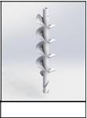**Auger:**

The Rover uses an Archimedean screw attached to the front of the Rover which can collect soil samples from up to 15 cm depth controlled using a linear actuator and a DC motor. The auger will be cased inside a cylinder with a lid at the lower end which will be controlled using a servo motor. After drilling, the auger is pulled up using the linear actuator collecting the soil over the former. A hollow cylinder containing the sensor probe will be attached to another linear actuator which will insert it into the hole drilled for measuring the sensor data from the soil. The soil will be pumped into the science kit containing different test tubes filled with chemicals for further experiments.

**Motors and Controls:**

The rover's traversal system contains four 24V-rated IG52 DC motors with encoders which achieve a speed of 210rpm. These motors are equipped with wheels of diameter 31cm. To ensure efficient and safe motor operation, we chose the SmartElex 30D motor driver, which can handle up to 30 Amps of current. A boost converter is used to step up the voltage drawn from the Li-PO battery to regulate the voltage supplied to the motor driver.

|  |  |  |  |
| --- | --- | --- | --- |
| **MOTOR** | **LOCATION** | **QUANTITY** | **DRIVER USED** |
| IG52 | wheels | 4 | SmartElex 30D |
| IG45 | Arm turntable | 1 | L298N |
| LA10 Linear Actuator 150N | Arm shoulder | 1 | L298N |
| LA10 Linear Actuator 150N | Arm Elbow | 1 | L298N |
| IG32 | Arm Wrist | 1 | L298N |
| IG32 | Arm End Effector | 1 | L298N |

**Processing :**

To ensure efficient and optimal performance of the robotic arm, we have allocated a Raspberry Pi 4 as its control system. This separate Raspberry Pi 4 serves as a specialized controller, solely focused on managing and operating the robotic arm's functionality.

The Raspberry Pi 4, known for its powerful processing capabilities, provides ample computational resources to handle the intricate control algorithms and operations required by the robotic arm.

By separating the control of the robotic arm onto its own Raspberry Pi 4, we can optimize the arm's control loop and response times, the separate Raspberry Pi 4 ensures that any potential issues or errors in the robotic arm's control system do not affect the overall operation of the rover. If a problem arises with the arm's control, it can be addressed and resolved independently without impacting the functioning of other critical systems on the rover.

For the traversal control of the rover, Arduino Uno is used. It is small and adaptable microcontroller board, with the ATmega328P chip. It includes 6 analog inputs, 14 digital I/O pins, and several communication ports giving versatility and flexibility over the system connections. It is compatible with Arduino software and libraries and offers a variety of power supply configurations.

|  |  |  |  |  |  |  |
| --- | --- | --- | --- | --- | --- | --- |
| **Board** | Processor | Processor Speed | Operating voltage | Static RAM [kb] | Digital IO/PWM pins | Flash Memory |
| Arduino Uno | Atmega 328p | 16 MHz | 5 V | 2 | 14/6 | 32 |
| Arduino Mega | Atmega 256o | 16 MHz | 5 V | 8 | 54/15 | 256 |

For the science analysis with multiple sensors, Arduino Mega 2560 has been used which is a microcontroller board based on the ATmega2560 chip, offering 54 digital I/O pins, 16 analog inputs, and communication interfaces like UART, SPI, and I2C. With 256 KB flash storage, 8 KB SRAM, and 4 KB EEPROM, it is suitable sensors which works at higher precession.

**Power Distribution System:**

Our rover will be equipped with a battery protection system and a power distribution system. The electrical components of the rover, including the robotic arm and motors for traversal, will be powered by four (22.2V) Li-Po batteries with capacities of 16000 mAh each, which will pass through a kill switch. The selection of Li-Po batteries over their Ni-Cd counterparts is based on their advantageous characteristics. Li-Po batteries are preferred due to their lighter weight, high efficiency, versatility, environmental safety, high discharge rates, and low self-discharge. To ensure optimal functioning, buck-boost converters have been employed to supply the individual components with their rated voltages of 5V, 15V, 12V, and 24V.To improve safety and control, the rover will have a kill switch for instantaneous electrical system shutdown in an emergency. This essential characteristic enables quick power flow termination to the components, providing quick reaction to urgent conditions.

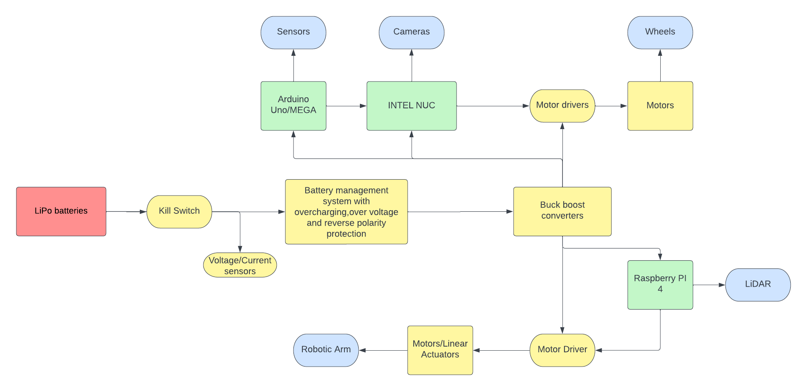

**Communication:**

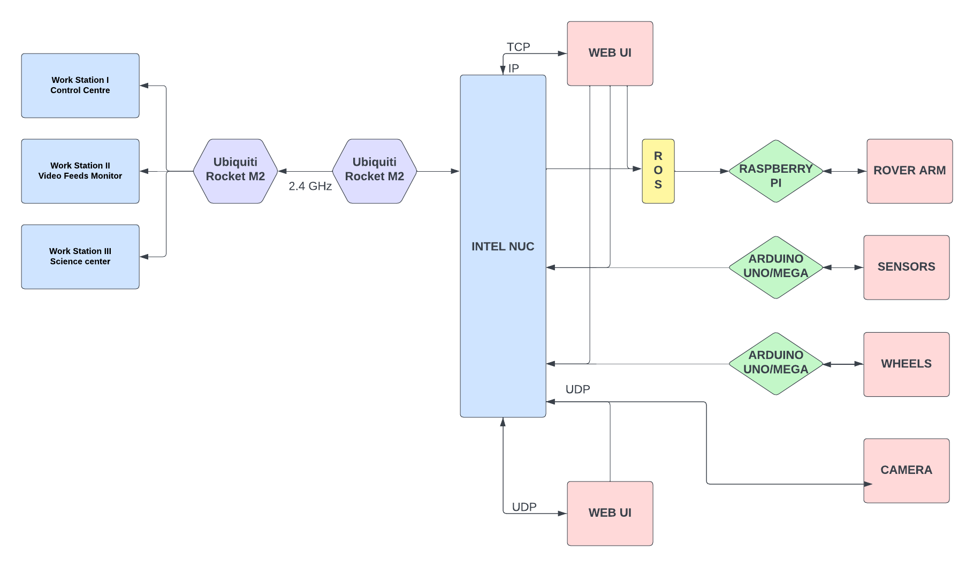 An Ubiquiti Rocket M2 with an omnidirectional antenna is installed on the rover as it was optimum for a range of governance of task. The GCS is equipped with a sector antenna mounted Ubiquiti Rocket M2 and a tracking system. 2.4GHz Frequency band was chosen after careful consideration of its throughput, range and the team budget. Using an omnidirectional antenna on the rover ensures comms connectivity irrespective of the rover’s yaw.

**Ground Control Station:**

A Web UI acts as a centralized interface that monitors and controls every functional unit of the rover and is hosted on the rover’s onboard computer. This minimizes unnecessary network strain and latency, maximizes portability, and ensures proper networking, enabling access to the core rover systems from any computer on the network.

The Control Centre receives feedback from all the subsystems making it easier to debug errors in the system. There are two modes to control the robotic arm. The Automatic mode runs the arm using Inverse Kinematics while the Manual mode grants control of every motor individually for more precise control. For video feeds, the system can operate USB cameras and IP cameras simultaneously over the network. The IP Cameras provide high-resolution video streams that are compressed before being transferred over the network using UDP protocol. The mission progress is tracked at the control station in real-time. The IMU sensors readings are utilized to reproduce a simulation of the orientation of the rover at the control centre.A screenshot of a computer

**Sensors :**

We will be using many sensors for various useful telemetry. Data pins of all the sensors will be connected to the Arduino Mega. The data acquired from all the sensors will be combined in a string packet and transmitted to the ground station.

A rover needs a large number of sensors to be able to traverse effectively. To accurately capture motion, it featured an MPU6050 that combines a 3-axis accelerometer and  3-axis gyroscope in a single compact package. This sensor module provides comprehensive motion detection capabilities, allowing the rover to detect changes in orientation and motion accurately. Additionally, we chose the LiDAR sensor LIDAR-053 EAI YDLIDAR X4 for reliable obstacle detection. The sensor uses laser technology to identify and measure obstacles accurately, further enhancing the rover's ability to traverse.

|  |  |  |  |  |
| --- | --- | --- | --- | --- |
| **SL no.** | **Sensor Type** | **Model no.** | **Purpose** | **Working Voltage** |
| 1 | Temperature and Humidity sensor | DHT -22 | To measure the atmospheric temperature and humidity. | 3.3V - 6V |
| 2 | Ultrasonic sensor | HC-SR04 | To measure the perpendicular dimensions of the rock sample. | 5 V |
| 3 | DC Voltage sensor | **-** | To measure the voltage difference in the Maintenance task. | 3.3V - 5 V |
| 4) | Soil moisture humidity sensor | **-** | To measure the important data like moisture of the soil. | 3.3V-5V |
| 5) | Piezoelectric sensor | - | To weigh the soil and rock samples by observing the change in output current. | 3.3V-5V |
| 6) | Inertial Measurement Unit (IMU) | MPU 6050 | To measure the rover joint motion and movement which would be used as input for Virtual Python and also while using Visual Odometry during navigation task. | 2.375V–3.46V |
| 7) | LiDAR | SmartFly YDLIDAR X4 | To sense the obstacles nearby and process for smooth traversal. | 4.8V-5.2V |
| 8) | Gas Sensors | MQ3, MQ5, MQ6, | To detect various gases like alcohol, ethanol, smoke, natural gas, lpg, butane,etc. | 5V |
|  |  | XENSIV PAS CO2 sensor | To detect the CO2 concentration at the location. | 3.3V – 12V |
| 9) | Spectral Sensor | Adafruit AS7341 | To detect colors and perform spectral analysis applications | 3V – 5V |
| 10) | Lux & Proximity Sensor | Adafruit VCNL4040 | To measure intensity of light . | 3V – 5V |
| 11) | pH Sensor | SKU SEN0161 | To measure the pH of the collected samples. | 5V |
| 12) | Infrared Soil Temperature | MLX90614 | To measure the temperature of the soil. | 3.3V – 5V |

|  |  |
| --- | --- |
| Robotic Arm | |
| SENSORS | DESCRCIPTION |
| **MPU-6050** | The MPU-6050 sensor module is typically integrated into the robotic arm's control system, allowing it to capture real-time motion data. This data is then processed by the arm's algorithms and used to calculate the arm's orientation, heading, and position. The accurate measurement capabilities of the MPU-6050 contribute to the arm's overall performance, allowing it to perform tasks with precision and responsiveness. |
| **Digital Dual DC voltmeter ammeter** | The Digital Dual DC Voltmeter Ammeter plays a crucial role in ensuring the safe and efficient functioning of the robotic arm by providing reliable measurements of voltage and current. Its digital display and dual functionality make it an indispensable component for monitoring and optimizing the arm's electrical system. |

**Technical Requirements:**

**Autonomous Traversal Task:**

After thorough research, we've concluded that though the A* algorithm is known for its optimality, it assumes prior knowledge of the environment, including the positions and shapes of obstacles, to construct the graph for path planning. Also,  though A* can handle relatively small state spaces efficiently, it could become computationally expensive and possibly impractical, to implement it in high-dimensional or continuous state spaces.

Therefore, we shall be using a modified implementation of the RRT* (Rapidly-exploring Random Tree) algorithm, which uses probabilistic sampling to explore the state space, thus making it suitable for high-dimensional continuous state spaces. It is known to be effective in handling complex and continuous motion models.

Why are we modifying it though? Because RRT is inherently stochastic - i.e., it has a high degree of randomness in the process of its random tree expansion. And so, the actual quality of the path is usually quite low and would involve significant post-processing to make it drivable.

Therefore, (taking inspiration from sources like <https://towardsdatascience.com/ros-autonomous-slam-using-randomly-exploring-random-tree-rrt-37186f6e3568>, <https://downloads.hindawi.com/journals/jr/2022/3477265.pdf>, <https://www.mdpi.com/1424-8220/23/2/1041>, <https://www.researchgate.net/publication/325473185_ROS-based_Path_Planning_for_Turtlebot_Robot_using_Rapidly_Exploring_Random_Trees_RRT>

and <https://github.com/ai-winter/ros_motion_planning>) - we’re implementing a version of RRT based exploration that requires a rectangular region around the robot to be defined in the RVIZ window using four points and a starting point for exploration within the known region of the robot.

Further, the unique design of the 270-mm polyurethane beach wheels on the rover greatly aids in providing a better grip and preventing slippage. Due to these wheels, it enjoys extra damping mechanisms to deal with sudden jerks and is less likely to tip over or become mired in unstable sand in the process of autonomously navigating the Martian terrain.

|  |  |
| --- | --- |
| **Task Requirement** | **Methodology** |
| Rover Localization | * The rover is localised in the given environment using laser-based SLAM (Simultaneous Localization and Mapping), as a ROS node called slam_gmapping (using GMapping, from OpenSlam). * The LIDAR sensors mounted on the rover will provide the system with the required odometry data, using which the slam_gmapping node will attempt to transform each incoming scan into the odometry frame, in the required format. |
| Path Planning | * Our rover will run on a modified implementation of the RRT* (Rapidly-exploring Random Tree) algorithm, which uses probabilistic sampling to explore the state space, thus making it suitable for high-dimensional continuous state spaces. * It is known to be effective in handling complex and continuous motion models, unlike the other popular choice i.e. A*, which is in fact rendered ineffective in high-dimensional and dynamic state spaces |
| **Cost Map/Occupancy Grid** | * The implemented package using GMapping, from OpenSlam, and a ROS wrapper is used for SLAM based localisation, using a ROS node called slam_gmapping using which we create a 2-D occupancy grid map. Also, we intend to use the localization library from the AMCL package as a controller for the robot, to ensure it moves to the right position. * Further, we intend to use the ROS package steer_drive_controller for steering the rover and for realtime-safe implementation and odometry publishing. |
| **Obstacle Detection and Avoidance** | * Using the data from the LIDAR sensors and the mapped-out visualisation (geometry_msgs from Twist, sensor_msgs from LaserScan, etc.), our implementation of obstacle detection and avoidance will steer the rover away from possible collisions. |
| **Processing Unit** | * Intel's Hades Canyon NUC (NUC817HBEH) is used on-board for processing required during the task. |
| **Modified double bogie mechanism** | * The suspension provides enough damping capabilities to go through rugged terrain and ensure a smooth traversal. |

**Maintenance task:**

|  |  |
| --- | --- |
| TASK REQUIREMENTS | METHODOLOGY |
| TASK AUTOMATION | a) **Automatic movement calculation**: The robotic arm uses inverse kinematics equations to automatically determine the angle configuration based on manually inputted target coordinates for the end effector.  b) **Automatic approach**: With feedback from sensors, the arm autonomously adjusts its links to the required angles, ensuring accurate positioning and efficient task execution. |
| TELEOPERATION | a) **Dynamic operator feedback**: Quadrature encoders measure the speed and direction of the rotating shaft, providing real-time feedback to the operator.  b) **Situational awareness**: IMU sensors, including accelerometers and gyroscopes, inform the operator about the current position of the arm's limbs.  c) **Operator's control interface**: The Robot Operating System (ROS) and a web-based UI facilitate monitoring and control of the robotic arm's operations. |
| END EFFECTOR’S PERFORMANCE | a) **Tools**: The two-claw mechanism for the robotic arm is used in both the maintenance task as well as the science task  b) **Operational robustness**: The end effector can rotate around its axis with the help of a dc motor. |
| MANIPULATOR’S PERFORMANCE | a) **Operational robustness**: The robotic arm is equipped with four DC motors and two linear actuators, which enhance maneuverability and control during maintenance tasks. With a reach  radius of 1000mm, the arm is capable of accessing a wide range of locations, ensuring effective operation and adaptability.  b**) Operational accuracy**: To achieve precise positioning, the robotic arm utilizes inverse kinematics calculations. This method enables the arm to calculate specific coordinates within the system, ensuring accurate and targeted movements for optimal task execution. |

**Collection task:**

|  |  |
| --- | --- |
| **Task Requirements** | **Methodology** |
| Cache detection | * **Once you are in close proximity to the target location, you can analyse the video feed to detect the presence of a green-coloured cache.** * **By setting upper and lower bounds for the green-coloured pixels, you can use image processing techniques to locate the cache within the video feed.** |
| Teleoperation | * **A specialized graphical user interface (GUI) is being developed, which will be hosted on the Ground Control Station (GCS) to facilitate the teleoperation of a rover.** * **The GCS will provide features such as simulation, video feed, and an individual motor control centre to support the operator during task execution.** |
| 5 degree of freedom for robotic arm | * For optimal performance in different tasks, the arm needs to have 6 degree of freedom which is provide at –  1. 1 dof – By turntable. 2. 2 dof – By arm joint. 3. 2 dof – By end effector. |
| Containers | * **To ensure proper storage of the cache, the airtight container is created using 3D printing technology. Additionally, slots are incorporated into the chassis design to accommodate the cache securely within the container.** |

**Preliminary Design:**

**Proposed Solutions**

**Science Task:**

**HYPOTHESIS:**

Our mission involves conducting a search for existing and extra-terrestrial life forms on Mars, utilizing both navigation and scientific analysis simultaneously. The navigation analysis will allow us to assess the rocky and rough terrain of the Martian surface, and the rover will come to a halt upon encountering red soil. We will employ a digital microscope to examine the texture and quality of the soil. The primary objective of our rover is to detect the presence of biomarkers or fossils on the Martian surface. To accomplish this, we will use aerogel sheets to melt the dry ice found on the surface of Mars and transfer the resulting liquid to a crater.

**I. Geological map of the Mars Yard:(add 3 figures/annotated photographs with proper description)**

Mars boasts a variety of geological features such as volcanoes, rivers, and impact basins. The planet's atmosphere is filled with impact craters, a testament to a time in its geological history when it experienced a significant bombardment of planetary debris. Older planetary surfaces tend to have a greater number of impact craters compared to younger surfaces. Furthermore, Mars is frequently engulfed by large, swirling dust storms that span across its entire surface on a daily basis. As a result, sand and dust are ubiquitous throughout the planet.

**II. Geological History:**

The Arcadia Planitia region on Mars exhibits a predominantly flat terrain, and there are indications of previous glaciation, along with ice deposits located relatively close to the surface. Geographical analysis suggests that the glaciation was extensive and occurred during a period of higher tilt for Mars, leading to more pronounced seasonal variations and fluctuations in ice accumulation and melting. Researchers have identified specific locations with a notable abundance of water-equivalent hydrogen, which may signify the existence of substantial subsurface ice. The presence of secondary craters further suggests the presence of shallow subsurface ice formations.

**iii. A falsifiable hypothesis and its justification:**

The rover's primary objective is to search for indications of extra-terrestrial life forms. It will capture data on soil texture and environmental conditions, which can provide insights into the site's potential to support life. Our main focus is to identify signs that could suggest the presence of microbial life. Specifically, we will be investigating extremophiles, organisms capable of surviving in extreme conditions. Our primary targets will be thermophiles, thriving in high temperatures, and psychrophiles, adapted to cold temperatures.

Through soil analysis, we aim to comprehend the texture of the soil and assess the availability of elements that could support life. Rock and soil samples will be collected from the Martian surface using an auger setup designed for sample collection. Chemical analysis will be conducted to examine the presence or absence of biomarkers such as proteins, carbohydrates, and lipids, which can provide insights into soil health.

Furthermore, spectrometric analysis will be employed to determine the presence of toxic elements and organic compounds. Microscopic analysis will assist in the search for endolithic structures, which could potentially provide further evidence of past or present microbial life.

Reference: <https://images.app.goo.gl/9q9VaU1U76KU61887>

**Sample Collection:**

The scientific module is equipped with the necessary testing equipment to detect the presence of existing or extinct life in soil samples. To facilitate extensive testing, the science soil tank has been specially designed with two compartments. For in-depth analysis, a customized screw auger is utilized to collect soil samples, while a cup line end effector attached to the manipulator is employed for analyzing shallow soil. The collected soil samples are then transferred into test tubes for further examination.

(Scientific justification)

**DIGITAL MICROSCOPIC ANALYSIS**:

The rover's digital microscope captures images of the soil sample, allowing analysis of important properties such as texture, particle size, water retention capacity, and soil type. Additionally, it enables the detection and study of endolithic structures and organisms, providing valuable insights into extant and extinct life forms.

**Chemical testing:**

Chemical analysis enables the identification of biomarkers such as proteins, carbohydrates, lipids, nitrogen, phosphorus, and potassium. These macromolecules provide crucial information about the potential presence of life in the soil and the overall soil health. The rover's onboard cameras will record the outcomes of the chemical analysis.

**SPECTROMETRIC ANALYSIS:**

A custom spectrophotometer setup with **three AS7265x sensors** and LEDs is used to detect atomic elements and organic compounds in the sample. It illuminates the sample at 18 different wavelengths, and the data is recorded and stored on the GCS. The sensor is placed on a 3D printed testing unit for precise light dispersion and accurate results.

**Thermal Imaging Sensor**

This is part of the dry sample analysis section. An OV2640 image sensor setup is installed to conduct thermal analysis, detecting infrared radiation emitted as heat signatures from living organisms

**SENSOR BASED ANALYSIS**:

An array of sensors will continuously monitor environmental and soil conditions on the rover. This includes **XENSIV PAS and DHT22** sensors for carbon dioxide, pH, temperature, and humidity measurements. Gas sensors detect CO2, alcohol, and methane. Additional sensors include PIR, metal proximity, lux, infrared temperature, metal proximity, soil moisture, spectral triad, and glucometer for various measurements. The data from these sensors helps determine soil condition and detect the presence of life forms.

**DRONE INVESTIGATION:**

We will enhance an existing drone by adding various sensors for terrain analysis and environmental monitoring. The drone will be equipped with a camera to capture visual data, which will be transmitted to the main system for further analysis. Climate conditions will be measured using a humidity and temperature sensor, while terrain mapping will be facilitated by a LIDAR-053 EAI YDLIDAR X4 sensor. To collect samples, a custom 3D printed casing will be used to attach a HEPA filter, and the collected samples will be analysed according to system requirements.

**System Structure:**

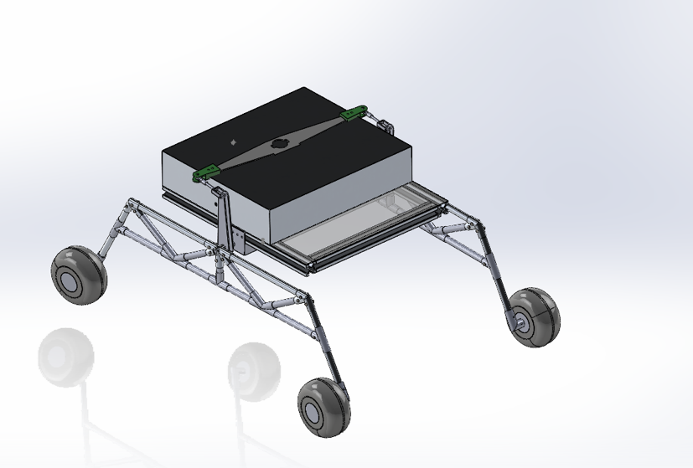

**Processing And control:**

To manipulate the speed of motors connected to the wheels, the Arduino Uno can adjust the width of the pulse sent to motor drivers or speed controllers. By changing the pulse width modulation (PWM) signal, the Arduino can effectively control the motor speed.

The code written for the Arduino allows for the execution of a single task at a time, providing good execution time and helping to complete the task within the specified time frame.

For measuring voltage at a specific socket, a voltage sensor can be interfaced with the Arduino Uno. The data received from the voltage sensor can be processed and displayed, ensuring accuracy up to two decimal points with an accuracy of 0.5.

**Mechanical System Design and Implementation:**

A modified double-rocker suspension design has been implemented for the rover’s suspension system. The 350mm hollow cylindrical links of the suspension system have been manufactured from Aluminium 6063-T6. The hollow links are designed to optimize the strength to weight ratio and provide protection for the motor wiring. The wheel motors are completely enclosed inside the tires with the help of a custom-made casing to protect them from any potential obstacles.

**Technologies Used:**

**Modified Double Bogie Mechanism:**

A four-wheel modified double rocker mechanism along with Polyurethane beach wheels are finalized for the rover. This suspension gives stability to the rover on significantly rough terrain and prevents the rover from toppling on steep slopes. The modified double rocker mechanism along with a truss support structure ensures that all the wheels always maintain contact with the ground. In case one of the wheels faces hindrance, the other wheels will be able to push the wheel over the obstacle. The modified double rocker mechanism accompanied by the beach wheels act as an ideal suspension for the uneven terrain that the rover will face.

**Inverse Kinematics:**

The structure of the arm will comprise a turntable, two links, and an end effector. For the movement of the links, high torque motors are required. The movement of the robotic arm will be automated using inverse kinematics. The orientation of each limb is obtained from the inertial sensors and used as feedback for the algorithm. The simulation of the arm will be manipulated to get the same orientation in the robotic arm. This allows ease of operation of the arm and allows for automation of high-level functions such as pick up an object, drop at a certain location, etc. without operator intervention.

**Microcontrollers:**

The **Arduino Uno** is a flexible microcontroller platform that uses cutting-edge technologies. The Microchip ATmega328P, a powerful microcontroller with an 8-bit RISC architecture, 32KB of flash memory, and 2KB of SRAM, powers the device. As a result of the board's extensive selection of digital and analog I/O pins, a variety of sensors, actuators, and external devices can be connected to and interacted with in an easy and seamless manner. It enables data sharing with other devices by supporting common communication protocols including UART, SPI, and I2C. The Arduino Uno also makes use of a powerful bootloader mechanism for simple firmware changes and programming. Because it is open-source, a vibrant developer community is encouraged, stimulating innovation and enabling the development of numerous projects and applications.

The **Arduino Mega** 2560 is an advanced microcontroller board that utilizes the ATmega2560 microcontroller. With its cutting-edge technology and 8-bit RISC architecture, it offers excellent performance. The board features a wide selection of digital and analog I/O pins, allowing for versatile connectivity with various sensors, actuators, and external devices. Equipped with 256KB of flash memory and 8KB of SRAM, the Mega 2560 excels at handling complex projects. It seamlessly supports communication standards like UART, SPI, and I2C for efficient data transfer. The Mega 2560 also incorporates a bootloader system for easy firmware updates and programming. With its open-source philosophy, it fosters an active development community and promotes innovation.

**Microprocessors:**

The **Raspberry Pi 4** is outfitted with cutting-edge hardware, including a quad-core ARM Cortex-A72 processor and the Broadcom BCM2711 SOC. It offers variants with 2GB, 4GB, or 8GB of LPDDR4 RAM for efficient multitasking. Due to the device's various USB ports, Ethernet, Wi-Fi, and Bluetooth connectivity options, connecting to other devices and networks is made simple. Because it offers hardware-accelerated video decoding and 4K video output, it is ideal for multimedia applications. The board offers additional features including GPIO pins, a microSD card port, and others that make it a versatile base for various applications.

The **Intel NUC** (Next Unit of Computing) is a cutting-edge, powerful, portable computing system. It is equipped with Intel CPUs, which offer a range of performance options. Despite its small size, it provides a variety of connectivity choices, including USB, HDMI, Ethernet, Wi-Fi, and Bluetooth. Because Intel NUCs enable high definition audio and video, they are suitable for multimedia applications. They are designed for a range of uses, such as gaming, small businesses, and home entertainment. Because of its powerful processing capabilities and flexible configurations, Intel NUCs provide dependable and efficient computing.

**CNC Machining:**

Computer Numerical Control (CNC) machine is used to precisely manufacture the robotic arm links and to create slots for weight reduction. CNC machine provides optimum dimensional accuracy with minimum tolerances, and a higher surface finish. It is a versatile method, aiding in cost and time reduction. 3 axes CNC machines will be utilized for intricate key components of the rover.

**3D printing:**

3D printing using ABS material will be used for end effector, auger, containers and other complicated parts on the rover. 3D printing enables manufacturing of intricate designs and mechanisms, where dimensional accuracy is of utmost importance. Since it is a costly and time-consuming method, this technology would be used only for a minimum number of components in the rover.

**Welding:**

Tungsten Inert Gas (TIG) welding with 4043 filler wire will be used for welding as it provides a precise, clean and low contamination welds with better holding capabilities. Aluminum is filler material is less prone to cracking and has an excellent penetration ability. TIG welding is a tried and tested method for welding of aluminum components, owing to its operating temperature range of 149 to 204 Centigrade.

**SLAM:**

The rover is localised in the given environment using laser-based SLAM (Simultaneous Localization and Mapping), as a ROS node called slam_gmapping (using GMapping, from OpenSlam). The rover continuously sends information about its position in the traversing environment to the system, and simultaneously maps the area in front of it using the odometry data obtained from the LIDAR sensors mounted on the rover. This is done by the slam_gmapping node, which will attempt to transform each incoming scan into the odometry frame, in the required format. And so, using slam_gmapping, we’ll generate a 2-D occupancy grid map from the laser odometry data (position [x, y, z] coordinates and orientation) sent by the rover.

We will also be using a ROS package named steer_drive_controller for steering the rover, since it is also useful for implementing realtime-safe navigation and odometry data publishing. We even intend to use the localization library from the AMCL package in ROS (a probabilistic localization system for a robot moving in 2D that implements the adaptive (or KLD-sampling) Monte Carlo localization approach), which is used as a controller for the robot,  ensuring that it moves to the right position.

**ROS:**

All autonomous and manual control of the rover’s navigation and detection is programmed using ROS. We use ROS’s various packages to gather all kinds of data - of which just the position coordinates and the orientation data are sent back to the ground station. The mapped data is visualised using the ROS Visualiser rviz. Using this mapped point-cloud data and using a modified implementation of the RRT* (Rapidly-exploring Random Tree) algorithm the rover will navigate through the terrain, reach all waypoints according to the planned course, come back to the initial position and generate a detailed report of its little manoeuvre.

**Core drone systems:**

**Frame:** We have used a plastic quadcopter Q450 Frame with wheelbase of 450mm, weighing 3.24kg

Propellers of size 10 x 4.5 cm have been used on each arm. Landing gear is used under the frame for

safe landing and take-off.

**Propulsion:**

Four brushless DC motors of power rating 920kV have been used. Brushless ESCs of

power rating 30A have been used to regulate the power supply to the motors.

**On-board Processing:**

Pixhawk 2.4.8 has been used for flight control. Raspberry Pi 3b+ has been

used for ARUCO tag scanning, along with Raspberry Pi camera module, and for path planning. Neo-M89

has been used for navigation. For GNSS, a Ublox Neo-M8N high precision GPS module with built in

compass is used. 915Mhz 100mW Mini Telemetry for wireless configuration of Mission Planner on the

pixhawk.

**System Breakdown Structure:**

**Rover Structure:**

**Team Structure:**

SEDS VIT is a student chapter within VIT University and it stands for "Students for the Exploration and Development of Space". SEDS VIT has three branches – Core, which conducts space education sessions within VIT, Outreach, conducts similar sessions in various schools and Projects, which works on real-life projects in this field.

Our team consists of 30 members divided into 4 departments- Mechanical, Electrical, Software and Management. These 4 departments are further divided into 6 sub-departments as shown in the table below.

**Safety System Description:**

**Electrical:**

A kill switch is designed in such a way that it shuts off every electrical component in case of an emergency situation. The kill switch operates similar to a normal switch acting as a link between the circuit and the battery, thus disconnecting it will cause an immediate shutdown.

LED strips have been attached to the front and back of the rover to indicate the rover’s activity, so that we can see which operation is being currently carried out by the rover to monitor each operation which is being carried out Colour and its operations:

1.Red: Autonomous operation

2.Blue: Manuel control

3.Flashing Green: Successful completion of leg

Overvoltage Protection Circuit - Overvoltage protection is a power supply features which cuts off the supply whenever the input voltage exceeds a pre-set value. For protection from high voltage surge, we always use overvoltage protection. Circuit consists Zener diodes and resistors that regulate voltage and protect the circuit from excess voltage. This circuit disconnects the output when the voltage exceeds the pre-set level. It’s located between the battery terminals and the power distribution board such that whenever the voltage level spikes above the pre-set value, no current reaches the power distribution board thus saving the components from damage.

High AWG Rating wires are used to ensure that wires do not melt

**Communication:**

The control application at GCS will have a stop button as an additional safety option to stop the entire rover at once or specific components like the arm motors, suspension motors, drill assembly, etc.

All rover activities will be suspended in case of a communication breakdown and won't be resumed until proper contact with the GCS has been made.

Emergency stop button has been integrated into the GUI to stop the rover's functioning and halt it.

According to the rule, Rover should be functional between +10 deg C to +30 deg C. Because of any condition, if the temperature of the surroundings increases to a specific limit, then all the functions will immediately shut down.

**Robotic Arm:**

Robotic arm position is locked in power down condition due to worm wheel design to help stabilize the arm. Manual arm control and its automation have been programmed to never result in a dangerous orientation by placing limits to how much the arm can move in different axes.

**Autonomous:**

The KILL switch is available to turn off the rover completely if there is any malfunction with the autonomy of the rover. The rover in its autonomous state is capable of detecting objects and avoiding them, and even if there is an event of collision the chassis is designed to handle it.

**Mechanical:**

The suspension links are hollow cylinders which provide strength to the suspension as well as protection to the electrical wires from dust, which go to the wheel motors from the chassis. All wires are secured using zip ties and insulation tape.

**Preliminary Final Budget:**

|  |  |
| --- | --- |
| **PROJECT BUDGET** | |
| **ROVER FRAME AND CHASIS** | |
| **Component** | **Amount** |
| Assorted bolts | $71 |
| Frame | $100 |
| Suspension Connector | $177 |
| Coupling shaft | $113 |
| T Slots | $115 |
| T Slot body | $110 |
| Cylindrical rods | $132 |
| TOTAL | $824 |
| **DRIVE AND ENERGY** | |
| **Component** | **Amount** |
| Motor Driver (4 pc.) | $350 |
| Motors (4 pc.) | $270 |
| Lithium polymer battery (4 pc.) | $1450 |
| Wheels (6 pc.) | $850 |
| Kill Switch | $4 |
| DC to DC converter (10 pc.) | $212 |
| Assorted wiring | $64 |
| TOTAL | $3200 |
| **Robotic Arm System** | |
| **Component** | **Amount** |
| Turn table gearbox | $183 |
| DC motor (3) | $95 |
| Linear actuator (2) | $180 |
| L298N Motor Driver | $6 |
| MPU 6050 | $4 |
| Voltmeter and ammeter | $9 |
| Kinect Sensor/cam | $83 |
| TOTAL | $560 |
| **Processing** | |
| Raspberry Pi 4 | $50 |
| Arduino uno (3 pc.) | $62 |
| Arduino mega (1 pc.) | $38 |
| Intel NUC | $600 |
| LiDAR | $85 |
| Primary Drive Camera (2 pc.) | $68 |
| Web camera (3 pc.) | $120 |
| TOTAL | $1023 |
| **Communication system** | |
| **Component** | **Amount** |
| Ubiquiti ROCKET M2 2.4GHz(2 pc.) | $280 |
| Ubiquiti Airmax Omni AMO-2G10 | $120 |
| Ubiquiti AirMax Sector Antenna AM-2G15-120 | $115 |
| CAT6A Cables | $4 |
| Joystick | $60 |
| TOTAL | $579 |
| **Science Task** | |
| **Component** | **Amount** |
| XENSIV PAS CO2 sensor | $67 |
| pH sensor - SKU:SEN0161 | $40 |
| Temperature & Humidity Sensor – DHT22 | $3 |
| Infrared Soil Temperature | $13 |
| DC motor pumps(3 pc.) | $8 |
| NEMA23 Stepper motor | $22 |
| TB6600 Stepper motor driver | $10 |
| Spectrometer sensor (Adafruit AS7341) | $37 |
| TOTAL | $200 |
| **Drone** | |
| **Body** | |
| **Component** | **Amount** |
| Pure Carbon fiber tubes | $22 |
| Landing Gear | $16 |
| Motor Mounts | $5 |
| Folding Mechanism | $8 |
| TOTAL | $51 |
| **Pixhawk** | |
| Pixhawk 2.4.8 Flight Controller | $145 |
| Pixhawk I2C Port Expand Board with cable | $3 |
| Pixhawk PPM Encoder Module with cable | $8 |
| Pixhawk Power Module with XT60 connector | $8 |
| TOTAL | $164 |
| **MOTOR** | |
| 5010 360KV High Torque Brushless Motor | $116 |
| **Total** | $6717 |

**Risk Assessment:**

|  |  |  |  |
| --- | --- | --- | --- |
| RISK | Impact | Probability | Mitigation |
| **Science** | | | |
| Chemical hazards (spillage of acids can damage on board equipment) | High | Rare | Using paper-based assays for chemical analysis |
| Exposure to Radioactive substances(Mars sample may contain radioactive substance too) | High | Medium | Samples can be carried back in sterile containers and analysed in sterile conditions only. |
| **Autonomous** | | | |
| The rover gets stuck in a specific place around obstacles | Very High | Occasional | The rover will go into a recovery state and backtrack to find the next best path. |
| There is only one path available and the path is not wide enough for the rover | Very High | Rare | The rover will keep getting into a recovery state but it is physically impossible to traverse. |
| The GPS may not be accurate enough because of 2.5m accuracy | High | Occasional | Use of GNSS would let us localise our rover better, but we cannot use it here due to the rules. |
| **Communications** | | | |
| Communication breakdown | High | Rare | When communication between rover and gcs breaks, the rover will come to a halt and backtrack to previous mark with proper network and troubleshoot to reconnect the system |
| Low signal strength | Medium | Rare | The signal strength and range of omnidirectional wi-fi routers can be increased. Directional antenna with tracker |
| Loss of data | High | Occasional | Because of any reason, if the rover has to restart, we may lose the previous data. So, we will have backup on our servers. |
| **PCB/PDB** | | | |
| Wire entanglement, wire bending | Low | Occasional | Using right angled connectors |
| Wire heating | Medium | Rare | Using wires of appropriate thickness |
| Wire space consumption | Medium | Rare | Using wire harness that holds bunch of wires together |
| Failure of rover due to subsystem failure | High | Rare | Using a safety management system that isolates faulty sub-system from main subsystem |
| Damage to PCB due to overheating | High | Rare | A fan is situated at the location of where a gap is added to the enclosure. In addition to this, a few vents are included for the sake of air flow |
| **ROBOTIC ARM** | | | |
| Laboured or uneven movement of the robotic arm. | High | Occasional | Periodic lubrication of the arm links and joints to ensure smooth movement of the arm. |
| Dust particles blocking camera. | Very High | Rare | Implementation of a cover that flips when required providing protection to the camera. |
| The inverse kinematics algorithm misreads from the garbage values procured by a certain sensor. | High | Rare | Specific sensors that possess certain libraries are used to make the code more intelligible. |
| Overloading of robotic arm | Low | Rare | The robotic arm links may bend under additional loading; hence it is designed in such a way that it can weigh up to 1.5kg of its weight |

**Appendix A: Pre-Radio Frequency Form 1**

|  |  |
| --- | --- |
| Field | Details |
| Team Name | Vyadh |
| Country | India |
| Person Responsible |  |
| System Name | Ubiquiti AirMax Sector Antenna AM-2G15-120 |
| Frequency | 2.3 GHz – 2.7 GHz |
| Channel Bandwidth | 20MHz |
| RF Transmit power | 10dBm |
| Antenna | 15dBi directional antenna. |
| Modulation | Orthogonal frequency-division multiplexing (OFDM), differential binary phase shift keying (DBPSK), differential quadrature phase shift keying (DQPSK), complementary code keying (CCK), 64 - quadrature amplitude modulation (64QAM), 16 - quadrature amplitude modulation (16QAM) |
| Description | The Ubiquiti AirMax Sector Antenna AM-2G15-120 is a high-performance sector antenna specifically designed for long-range point-to-point (PtP) and point-to-multipoint (PtMP) wireless connections. With a gain of 15dBi and a broad beamwidth of 120 degrees, this antenna provides excellent coverage over a wide area. Its robust construction ensures durability and resistance to harsh weather conditions, making it suitable for various outdoor environments. |

**Appendix A: Pre-Radio Frequency Form 2**

|  |  |
| --- | --- |
| Field | Details |
| Team Name | Vyadh |
| Country | India |
| Person Responsible |  |
| System Name | Ubiquiti Airmax Omni AMO-2G10 |
| Frequency | 2.35 - 2.55 GHz |
| Channel Bandwidth | 20MHz |
| RF Transmit power | 50mW EIRP configurable up to 1.4W |
| Antenna | 10dBi omnidirectional antenna |
| Modulation | Orthogonal frequency-division multiplexing (OFDM), differential binary phase shift keying (DBPSK), differential quadrature phase shift keying (DQPSK), complementary code keying (CCK), 64 - quadrature amplitude modulation (64QAM), 16 - quadrature amplitude modulation (16QAM) |
| Description | airMAX Omni is a Carrier Class 2x2 Dual Polarity MIMO Omnidirectional Antenna that was designed to seamlessly integrate with RocketM radios |



**=**